* **How the task was divided**

One of the reasons to choose this kind of company will be because each member of the group currently works in the food industry and as a supervisor and manager, besides we know the big problem of ordering supplements on many websites can be pretty annoying for the fact of prices or if the supplement is in stock or not. So we discussed and decided the main goal of our company would be to help the big companies and make life at work much easier.

Instead of purchasing each supplement on different websites, our company would have it all in one place and all the necessary information for suppliers.

The most reasonable thing to do was to create a vote in the WhatsApp group so that each person in the group could choose the area of ​​their preference. And also we created a group on Github to post all of our files about the CA, to organize everything and to keep in touch with.

| ***Kevin*** | Management | Planning Process | Gannt chart |
| --- | --- | --- | --- |
| ***Fernanda*** | Research & Development | Main purpose  Introduction | The writing part |
| ***Heloisa*** | Sales & Marketing | Development process | Website |

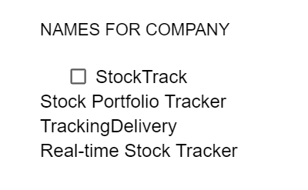

Prove of the examples of the name company

We thought the name StockTrack would make more sense for the fact of the main company.